 | 14.1.5 Editors - Video Sequence Editor - Header - Navigation Menu
Table of content
Navigation menu 1
Play Animation 1
Jump to Previous Strip 1
Jump to Next Strip 1
Jump to Previous Strip(Center) 1
Jump to Next Strip(Center) 1
Range 2
Set Preview Range 2
Set Preview Range to Strips 2
Clear Preview Range 2
Set Start Frame 2
Set End Frame 2
Set Frame Range to Strips 2

Navigation menu

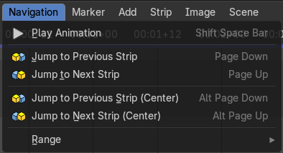
This menu exists in Sequencer view type.

Play Animation
Plays the movie.

Jump to Previous Strip
Jumps to the start of the previous strip.

Jump to Next Strip
Jumps to the start of the next strip.

Jump to Previous Strip(Center)
Jumps to the center of the previous strip.

Jump to Next Strip(Center)
Jumps to the center of the next strip.

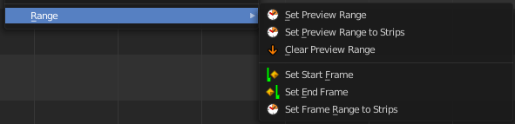
Range
Play range related functionality. Most of it can also be adjusted in the play elements in the timeline editor.

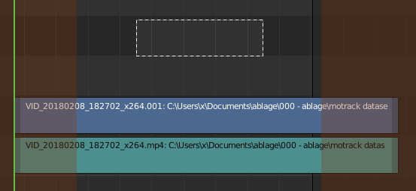
Set Preview Range
Calls a border select tool that allows you to set the range of the preview.

Set Preview Range to Strips
Sets the width of the preview range to the length of the strips.

Clear Preview Range
Removes the preview range.

Set Start Frame
Sets the current frame as the start frame for playback.

Set End Frame
Sets the current frame as the end frame for playback.

Set Frame Range to Strips
Sets the start and end frame to the start and end frames of the strips in the sequencer.

